**Systems Training Guide**

**Performance Portal**

**Getting Started**

Corporate Planning & Intelligence







Greater Manchester Fire and Rescue Service

Policy Template (Draft)

July 2012

# Contents

Contents 2

Document Version Control 3

Introduction 4

System Overview 4

How to Access the System 4

How to Use the System 6

Home Page 6

Corporate Scorecards 8

Incident Analysis Tool 11

Incident Analysis – Quick Stats 11

GMFRS Performance Overview 14

Borough/Station/Watch Performance 16

Accidental Dwelling Fires Dashboard 26

Incident KPI Tool 28

Incident KPI Framework Tool 32

Printing the Dashboards 38

Accessing the ‘Raw’ data 40

Links to other Systems 41

Exporting Data 42

Help and Support 44

# Document Version Control

|  |  |  |
| --- | --- | --- |
| **Document Version Control** | | |
| **Document Version** | **Date** | **Document Author** |
| 1.0 | 08/09/2014 | Maria Kershaw |

|  |  |  |
| --- | --- | --- |
| **Approval Process** | | |
| **Approval agency** | Systems Training and Support Manager | |
| **Document Owner** | Paul Sharples | |

|  |  |  |
| --- | --- | --- |
| **Related Documents** | | |
| **Hints & Tips** | * N/A | |
| **Policy & Procedure** | * N/A | |
| **Guidance** | * N/A | |
| **External** | * N/A | |

# Introduction

This document has been created to help you in ’Getting Started’ using the Performance Portal. The document contains useful information about the portal and guidance on how to access and navigate around the system itself.

* This document has been created using a test version of the system. The data displayed is for illustrative purposes only.

# System Overview

The Performance Portal is a one stop shop for all relevant performance information. The system has been designed so that it’s simple to use, accessible to everybody and does more than just report the numbers.

The dynamic user friendly style dashboards, gives you the ability to drill down into further information by a simple click.

# How to Access the System

The Performance Portal can be accessed via Big Red. Click Tools

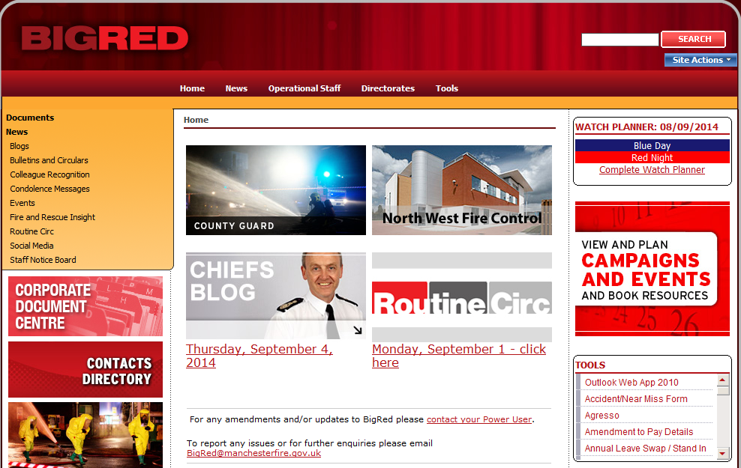

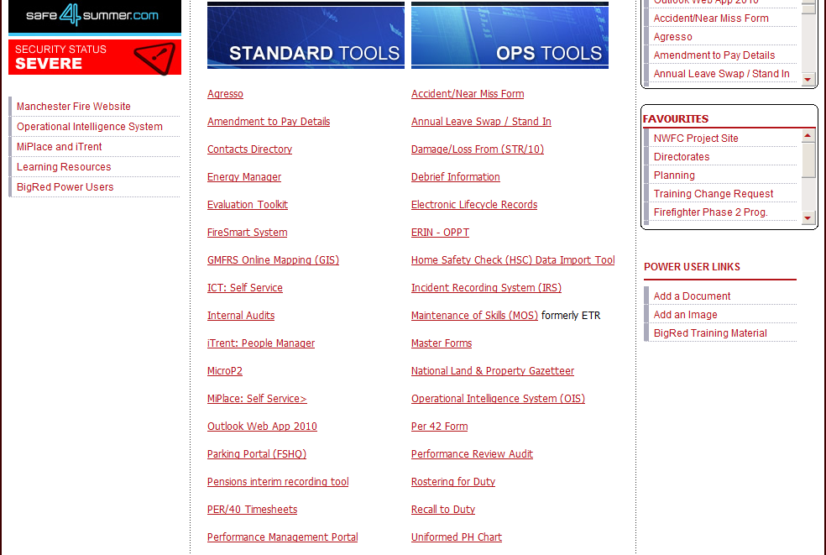

Under Standard Tools, click the Performance Portal link.

# How to Use the System

## Home Page

The Home Page is the first screen that you see when you access the system.

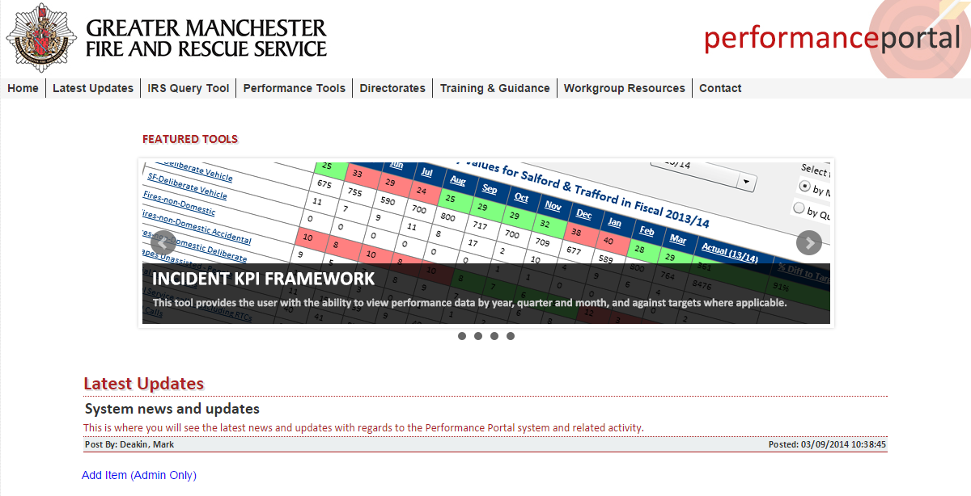

From here you can access each of the dynamic dashboards, as well as other useful tools/resources.

* Some functions are currently under development and will be available in future phases.

When you hover over any of the available menus, the relevant information/links will display directly below.

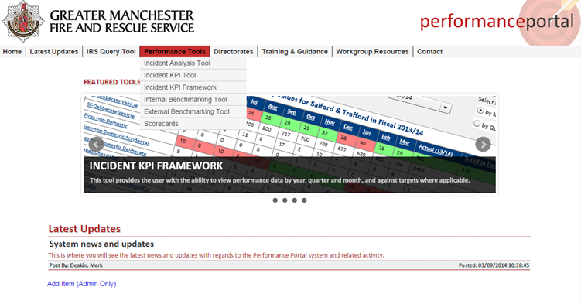

On the Home Page you will also find any news and updates regarding the system, details of who to contact should you require any help or assistance, and links to the associated training materials.

To return to the Home Page from any of the dashboards, you will need to click  icon.

* Please be aware that using the ‘Back Arrow’ within Internet Explorer will not work.

## Corporate Scorecards

The Corporate Scorecards show performance against all corporate performance indicators aligned to our 21 delivery goals at a variety of levels, from Organisational performance to Area, Borough and Station.

The dashboard can be accessed from the Performance Tools menu on the Home Page.

Below is the default view of the Corporate Scorecards dashboard.

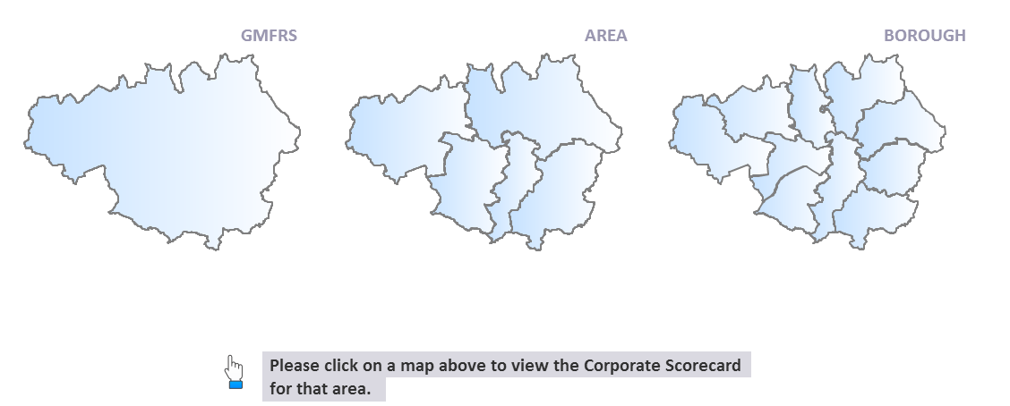

You would simply click on one of the relevant maps, to view that level of performance.

For this example I have selected the GMFRS map to view performance at an Organisational level. Here is where you choose your specific criteria.

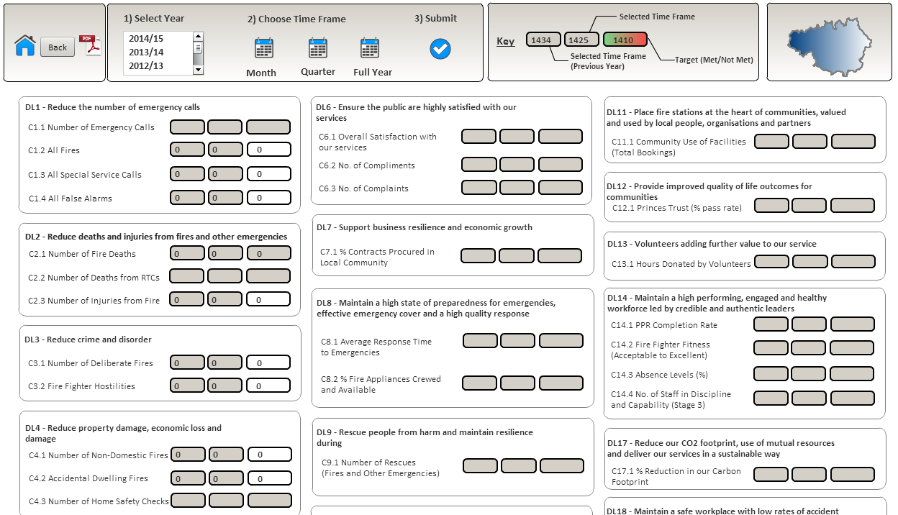

Once selected you click  to submit.

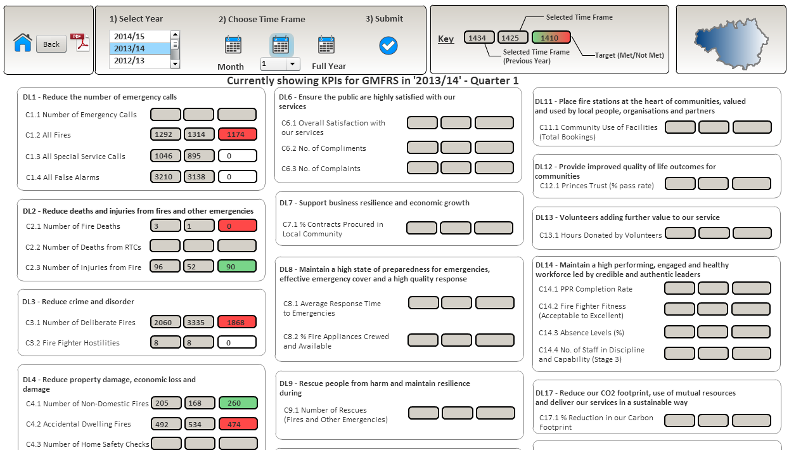

The dashboard will then be populated with information based on your specified criteria.

* Please be aware that some KPI’s will not currently be populated as they are in development.

The Key 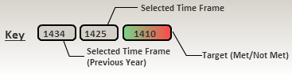 explains what the data displayed relates to. Where there is a target, these will show either red or green depending on whether the performance indicator is on or off target. If there isn’t a target these will be shown in white.

Where a measure has data attached to it, you can click on it and drill down to view further analysis of the data. For this example I have selected ‘c4.2 Accidental Dwelling Fires’.

The following table will be populated, showing performance against the chosen measure at various levels.

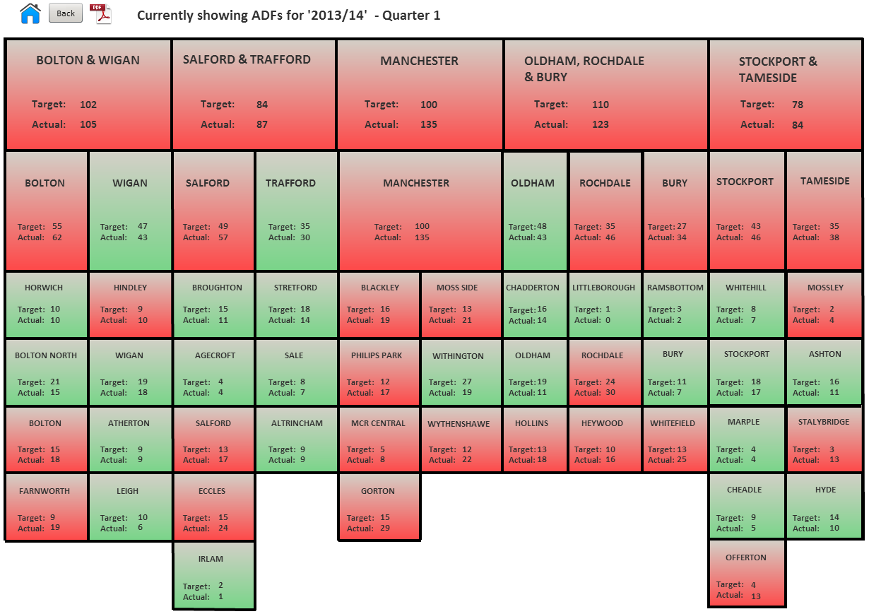

To return to the Home Page click 

## Incident Analysis Tool

The Incident Analysis Tool provides a one stop shop for all relevant incident performance information and allows us to interrogate the data at various levels to gain a better understanding of our performance.

The dashboard can be accessed from the Performance Tools menu on the Home Page.

### Incident Analysis – Quick Stats

Here you have the option to filter by Fiscal Period or by Date Range

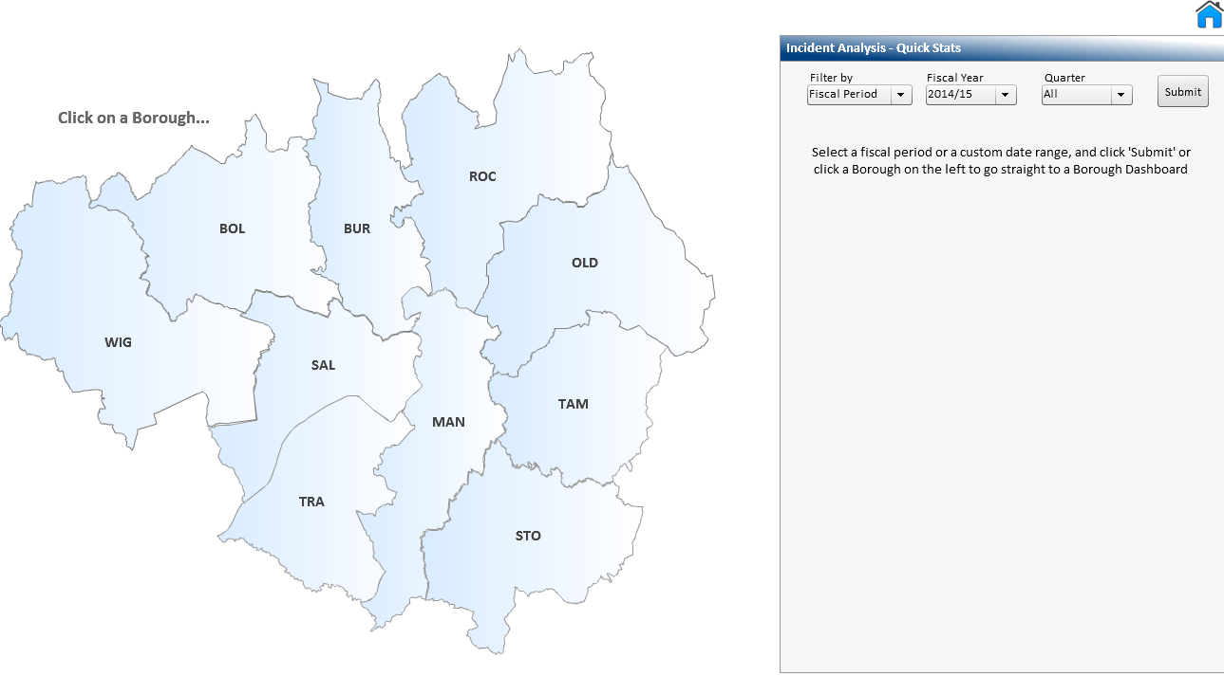

When you select Fiscal Period, you then need to choose a Fiscal Year from the list. If you want a full year then you would select the option ‘All’ alternatively you can choose a specific Quarter from the list, Q1, Q2 etc. You would then need to click the Submit button.

If you choose the option to filter by Date Range, the following fields will display:



Click the  icon in both the **From** and **To** fields as this will display a calendar from which you can select the required dates from.

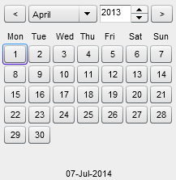

Navigate to the required month and year and select the date.

The fields will then be populated with the dates selected. You would then need to click 

You will be presented with the following chart, displaying the number of Fires, Special Services and False Alarms based on the criteria you specified.

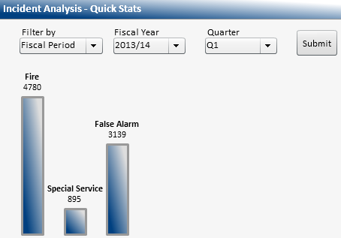

You can drill down further by clicking on the relevant bar.

For this example I have selected Fire.

The system will then provide further analysis.

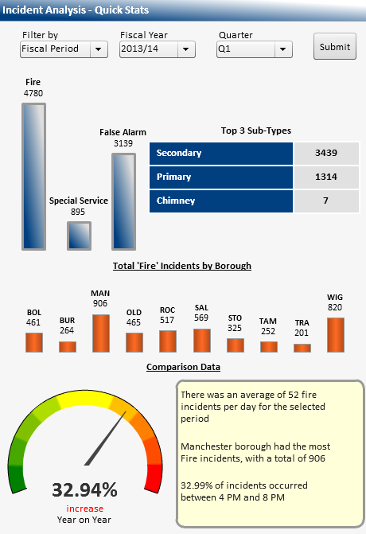

2

1

4

3

1. The top 3 subtypes of Fire.
2. The total Fire incidents by Borough.
3. The dial gives us a visual representation of the performance, compared to the same period the previous year.
4. The text box provides us with some basic analysis about the chosen incident type.

### GMFRS Performance Overview

Once you have submitted your query and the graph has displayed, the following button will be available at the bottom of the screen  Click the button to access the dashboard. The following will display.

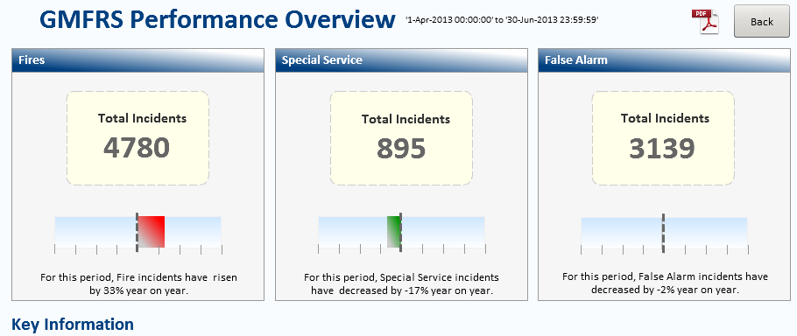

The dashboard allows us to view and analyse performance at a Corporate level. You will see the number of Fires, Special Services and False Alarms for the chosen period, along with a comparison to the same period the previous year.

To analyse the data further, you would simply click on the Incident Type Link.



For this example I have selected Fire.

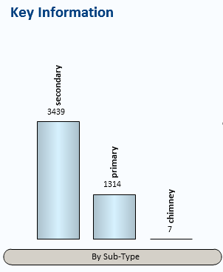

The chart shows us the total number of Fires for the top 3 subtypes. We can drill down further into the data by clicking on the relevant bar. For this example I have selected secondary.

The system will then provide us with a breakdown by Category and by Borough.

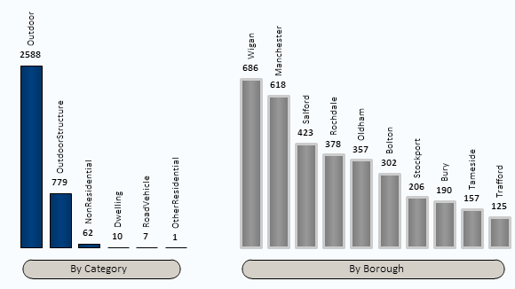

At the bottom of the dashboard there is also further information for us to see.

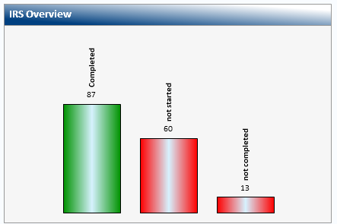

The IRS Overview shows the number of incident records which have the status of Completed, Not Started or Not Completed.

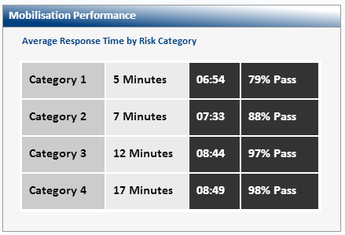

The Mobilisation Performance displays the Average Response Time and percentage pass rate by Risk Category. This is for the first pump only.

Click  to return to the previous screen.

### Borough/Station/Watch Performance

To access the Borough dashboard you would need to click on the Borough on the map.

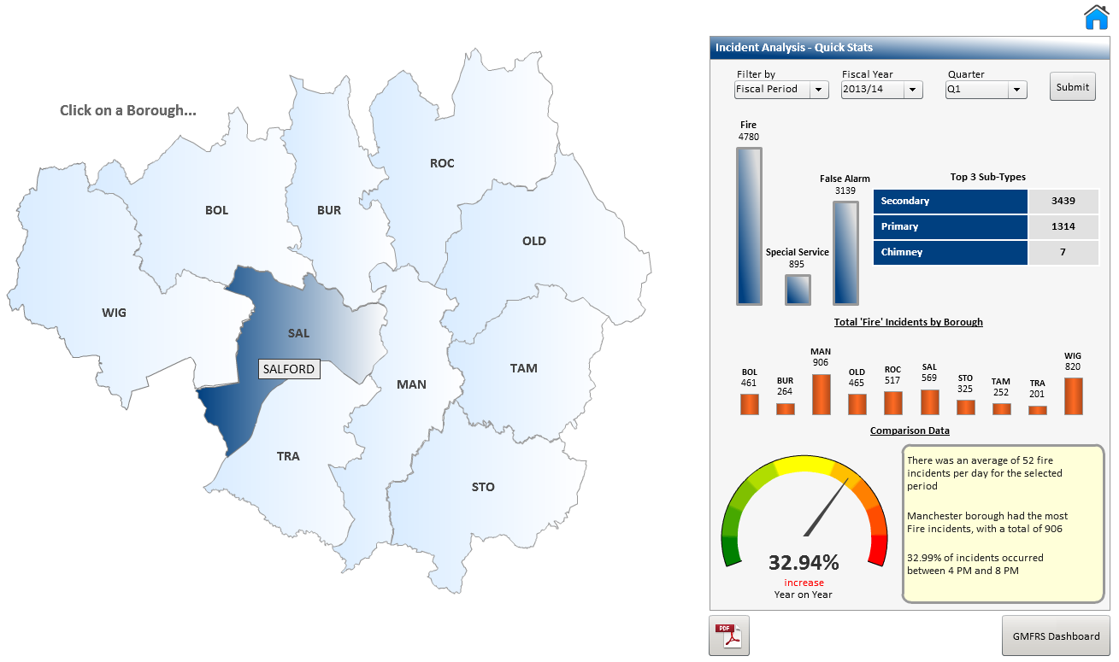

For this example I have selected Salford.

You will be presented with the following screen.

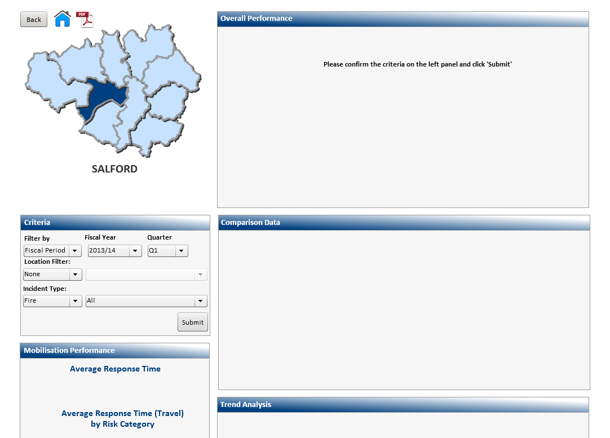

If you had used the **Incident Analysis – Quick Stats** then the criteria that you had specified would automatically be pulled through.

Click  to confirm the criteria.

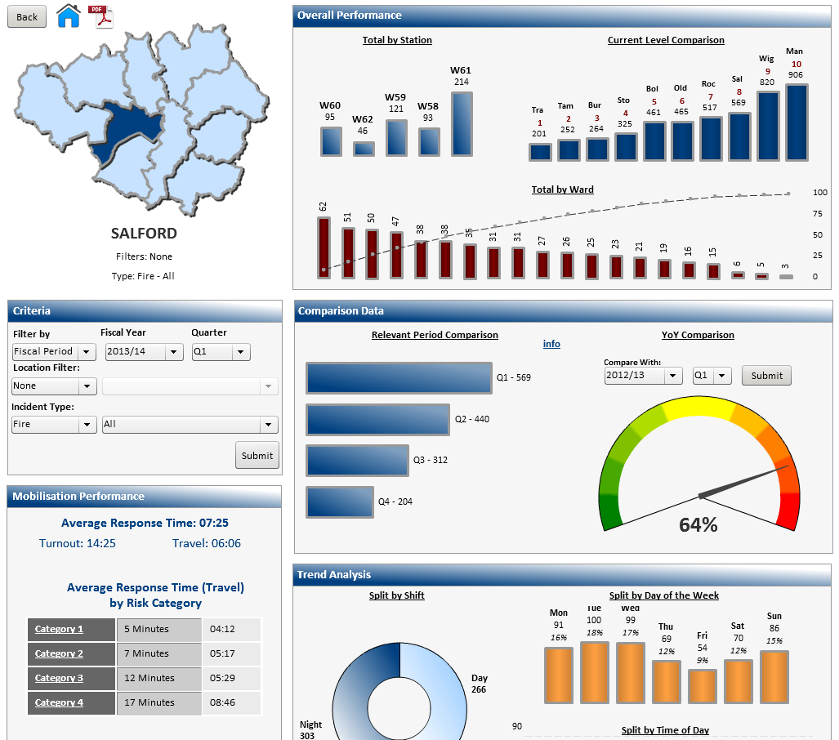

The dashboard will then be populated with information based on your specified criteria.

You may wish to analyse this data further, e.g. to look at a specific Fire Type. To do this you would need to apply a filter.

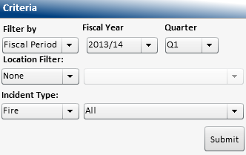

Click to display the list of Fire Types

For this example I have selected ‘Primary – All’

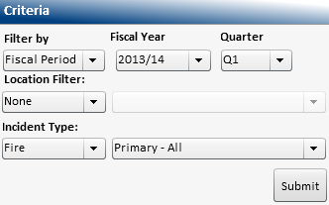 Then click 

The dashboard will now display the amended criteria.

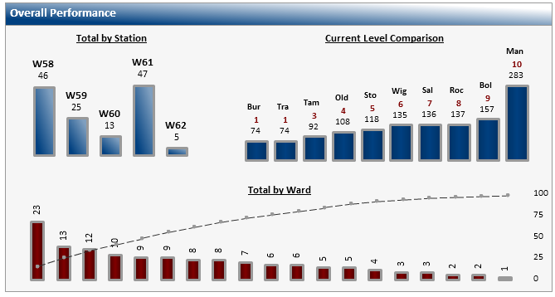

3

2

1

1. Here we can see the total number of all Primary Fires by Station.
2. The Current Level Comparison gives us the total number of all Primary Fires by Borough ranked in order from the lowest to the highest.
3. The pareto chart displays the total number of all primary Fires by Ward. (You would need to hover over the bars to display the Ward names). The chart shows the Wards with the highest number of incidents first, as well as the percentage number of incidents in a ward. This helps us to focus on any improvement activity on the Wards with the highest percentage of incidents.

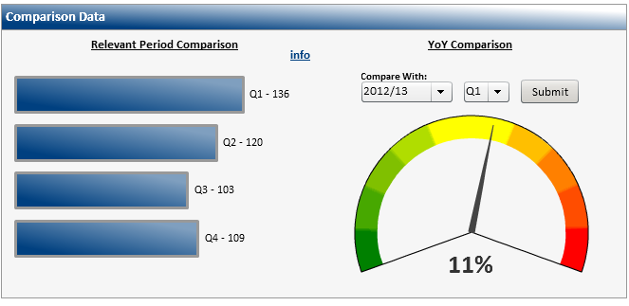

2

1

1. The information displayed within this chart, is based on the initial data selected. (In this example the total number of all Primary Fires for 2013/14 Q1 for Salford Borough). It also displays data based on the same criteria for the other quarters within the same year e.g. 2013/14
2. The dial gives us a visual representation of either a percentage reduction/increase in the number of incidents compared to the same period the previous year.

* You may change the criteria you specified at any time by changing the options within the criteria section and clicking submit.

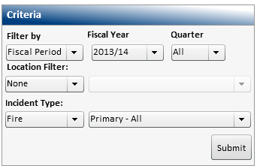 Selecting ‘All’ will display the full year.

Click  to confirm the criteria.

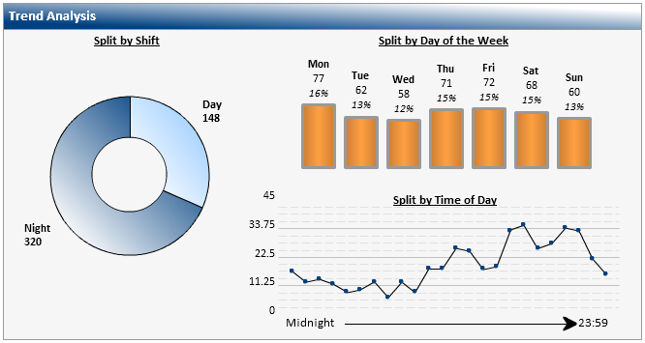

2

3

1

1. This display the total number of all Primary Fires for 2013/14 split by shift (day/night).
2. The chart displays those same numbers of incidents split by the day of the week when they occurred.
3. This graph shows us the number of incidents that occur on each hour of the day. (You would need to hover over the dots to display the actual times). By clicking on a particular day of the week on the above, the graph will change.

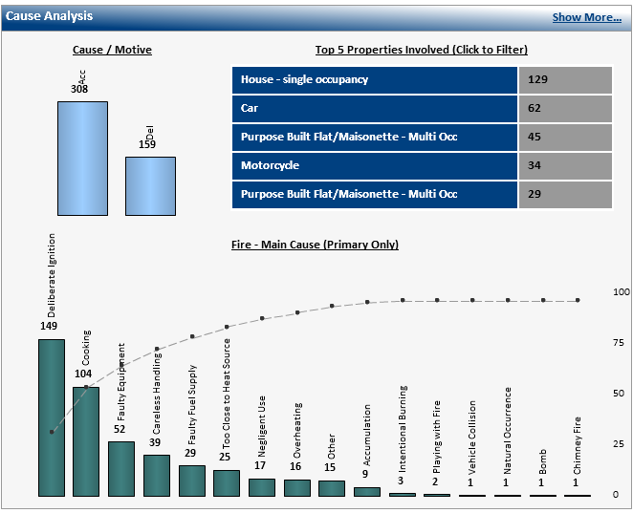

2

3

1

1. Here we can see the total number of all Primary Fires for 2013/14 split by motive (Accidental/Deliberate).
2. The table shows the same number of incidents split into the 5 top property types. (You are able to click on any property type listed and in doing so the data selected would be displayed).
3. The pareto chart displays the fire causation, showing the highest number first as well as the percentage number. This helps us to focus on any improvement activity on the causes with the highest percentage.

The system also allows us to analyse the data further, to do this you would need to click on the link  which will display a further breakdown.

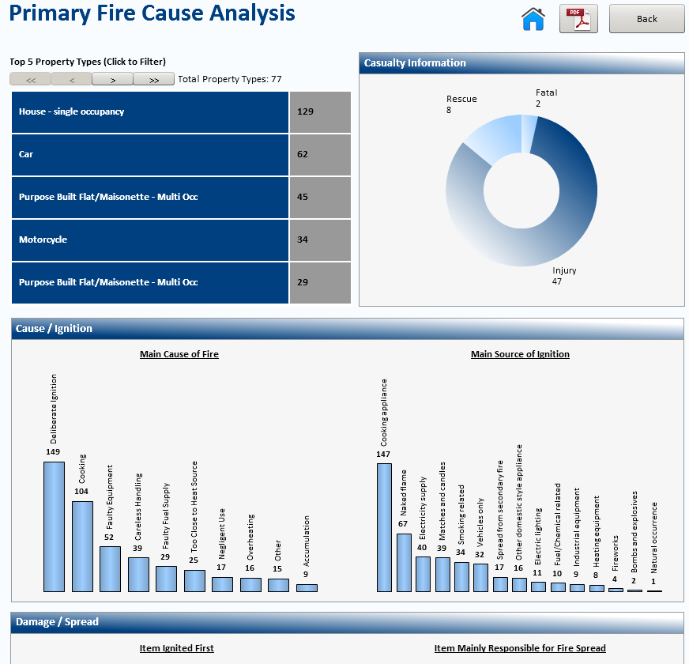

You can click on any property type listed and in doing so the data selected will be displayed.

The chevrons  at the top of the screen allow you to scroll forwards and backwards through the pages of data.

The remainder of the screen provides us with further analysis.

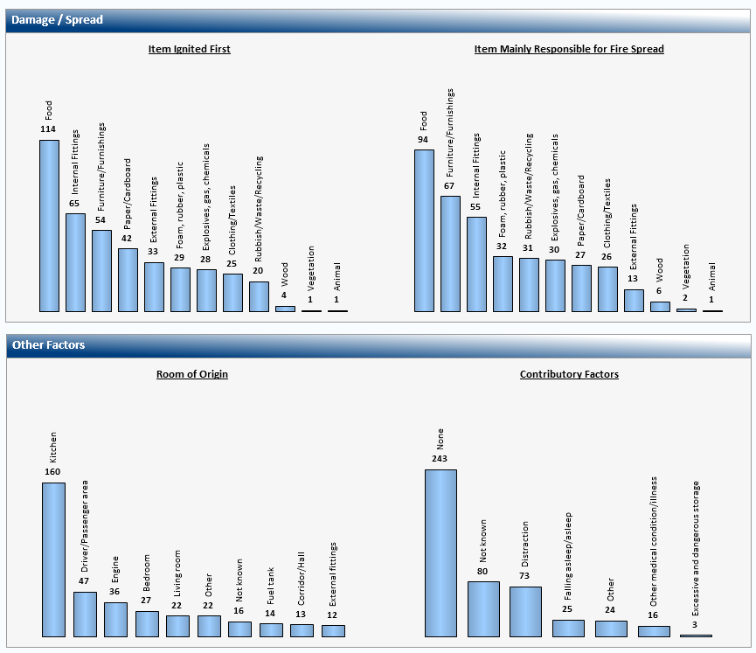

To return to the previous screen, you would need to scroll back up to the top of the screen. To go back to the previous screen click 

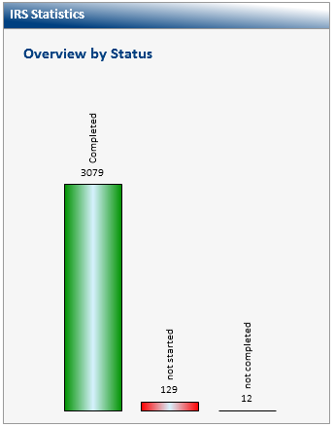

The IRS Statistics shows the number of incident records which have the status of Completed, Not Started or Not Completed.

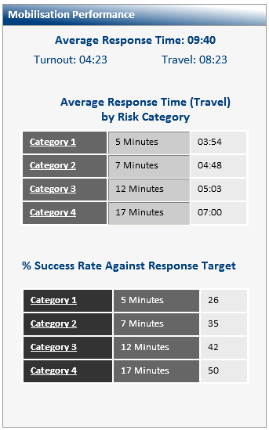

The Mobilisation Performance displays the Average Response Time by Risk category.

We can also see the percentage Success Rate against Response Targets.

As well as viewing performance at a Corporate and Borough level, the system also has the ability to enable you to view performance at Station level. To do this you need to include the Station into your criteria and click submit.

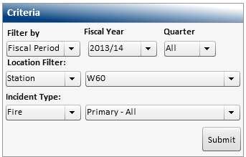

For this example I have selected Station – W60 (Agecroft)

The dashboard will refresh and the information displayed will now relate to the Station selected. In this example, Agecroft.

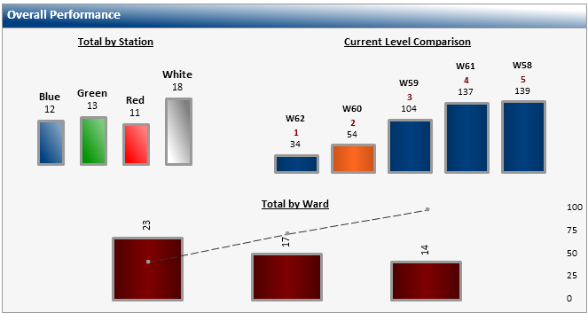

3

2

1

1. Here we can see the total number of all Primary Fires by Watch.
2. The Current Level Comparison, gives us the total number of all Primary Fires by Station, ranked in order from the lowest to the highest. You will see that the Station that you are currently looking at is highlighted.
3. The pareto chart displays the total number of all Primary Fires by Ward. (You would need to hover over the bars to display the ward names).

When the Station is selected, the Mobilisation Performance changes to include the ability to display mobilisation by Watch, by selecting from the dropdown list.



The remainder of the screen is as described earlier.

### Accidental Dwelling Fires Dashboard

The Accidental Dwelling Fires dashboard becomes available when this incident type is selected.

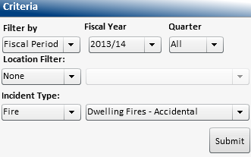

You would need to click on the link

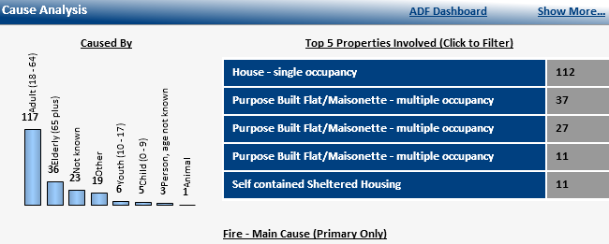

The dashboard allows us to quickly and easily analyse performance specifically for Accidental Dwelling Fires

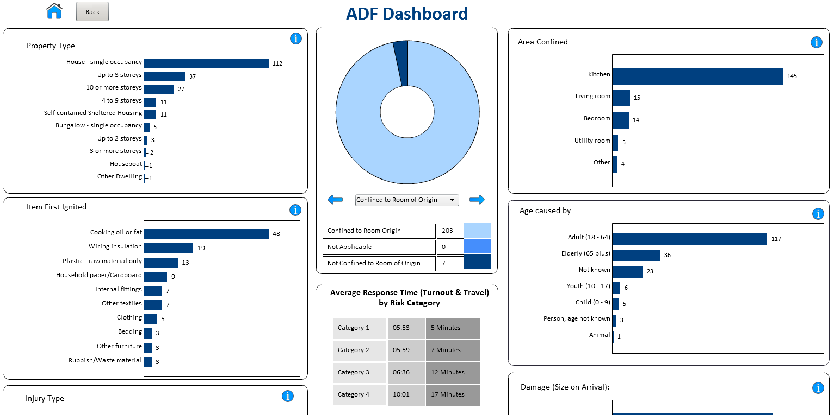

This is done using a variety of charts and pick lists with drill down functionality to help all round performance to be easily understood.

If you need further clarity of the data being displayed, you can find further information by clicking  wherever you see it displayed.

To change the criteria, click the dropdown arrow and select from the list.

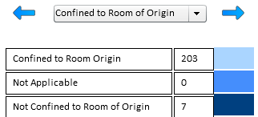

The dashboard will refresh and display data based on the option selected.

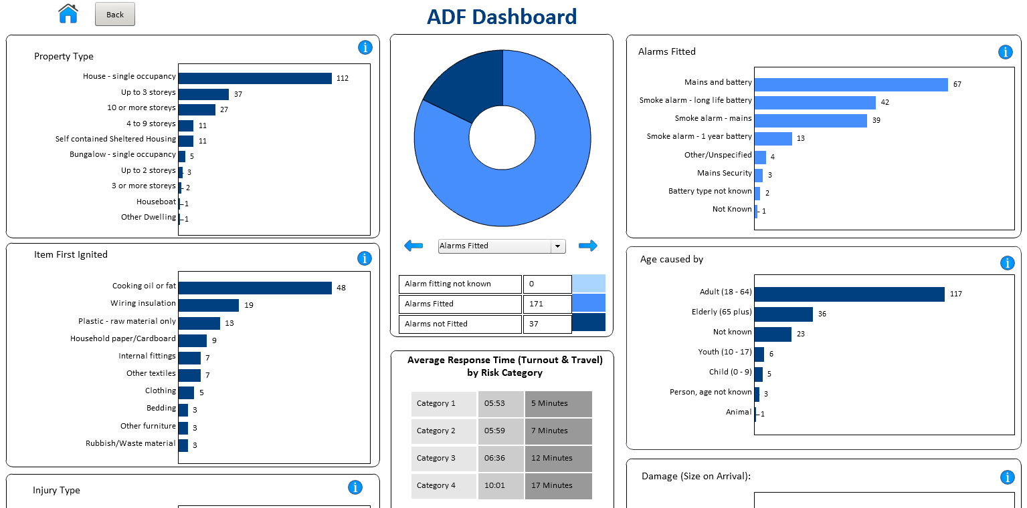

* Some of the sections may contain more than one level of detail when using the drill down facility.

To return to the Home Page click 

## Incident KPI Tool

The Incident KPI Tool provides a snapshot of performance against targets (where applicable) at Corporate, Area, Borough and Station level.

The dashboard can be accessed from the Performance Tools menu on the Home Page.

Below is the default view of the Incident KPI Tool dashboard

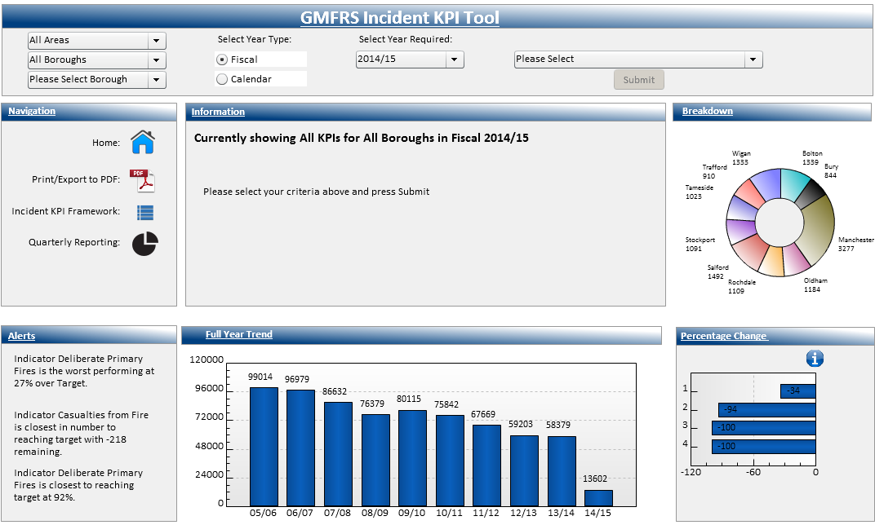

To continue to look at performance at a Corporate level, you do not need to change these fields.

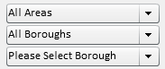

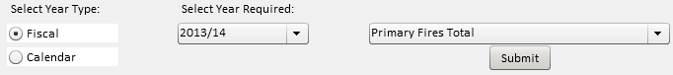

You have the option to select either a Fiscal Year or a Calendar Year. Select the required year and KPI from the list of options. Click 

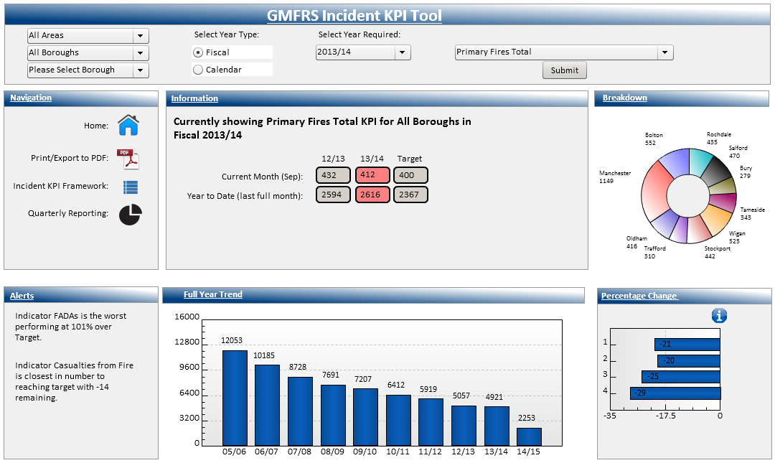

The dashboard will refresh and display data based on the criteria specified.

If you need further clarity of the data being displayed, you can find further information by clicking on the  wherever you see it displayed.

To display information for an Area, simply select the Area from the dropdown list.



Click  as before, the dashboard will refresh and display data based on the criteria specified.

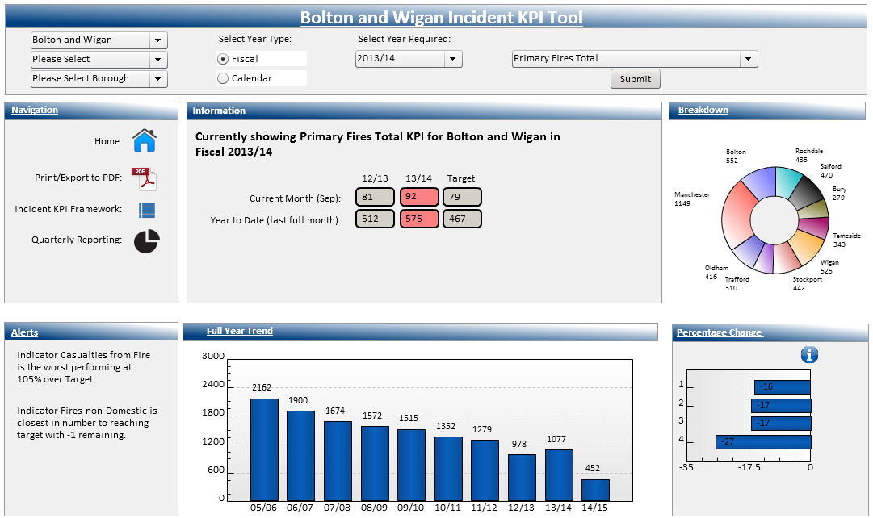

The title of the dashboard will also update. You will also notice that the dashboard has displayed even further data as I included an Area into the criteria.

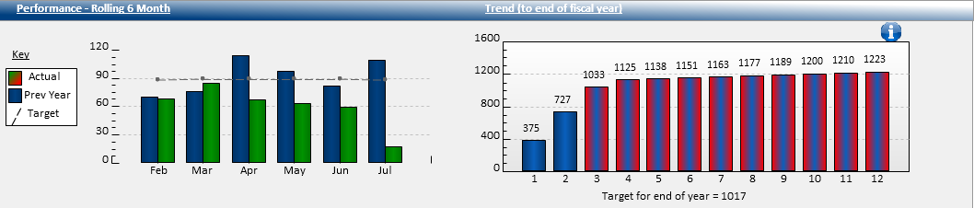

You can also view the information at a Borough/Station level. Click to select the Borough and Station from the dropdown lists. (You can just select a Borough).



Click  as before, the dashboard will refresh and display data based on the criteria specified.

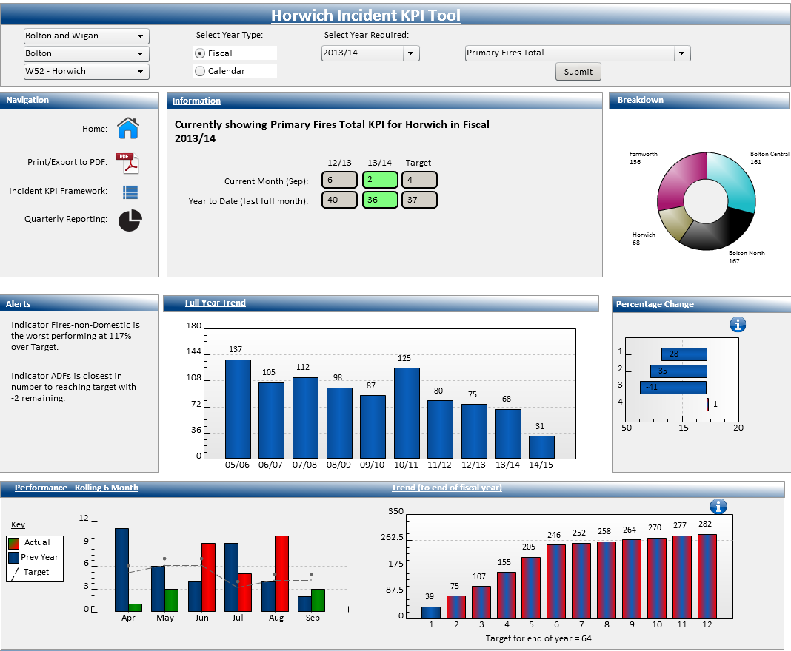

When you include a Borough and/or Station into your criteria, again the dashboard contains even further data.

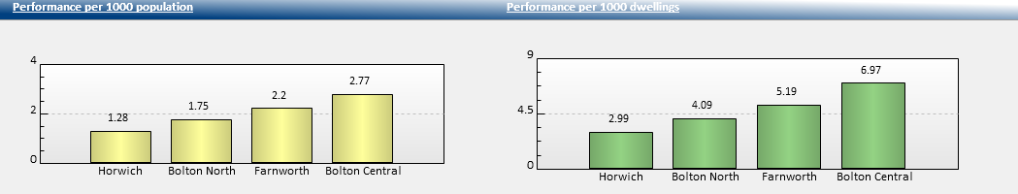

To return to the Home Page click 

## Incident KPI Framework Tool

The Incident KPI Framework Tool provides us with the ability to view performance per KPI by Year, Quarter, Month and against targets where applicable.

The dashboard can be accessed from the Performance Tools menu on the Home Page.

Below is the default view of the Incident KPI Framework Tool

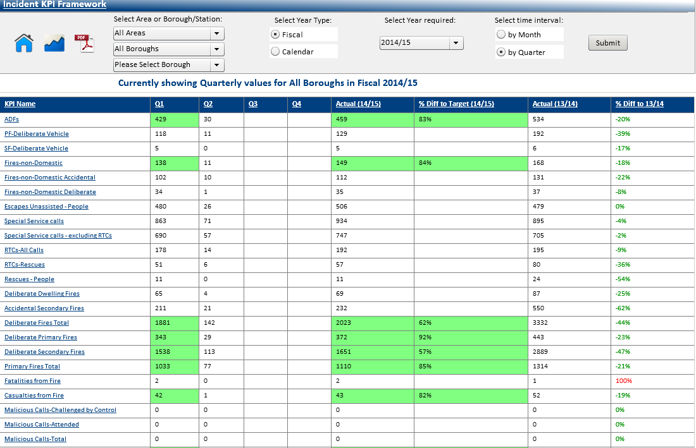

To continue to look at performance at a Corporate level, you do not need to change these fields.



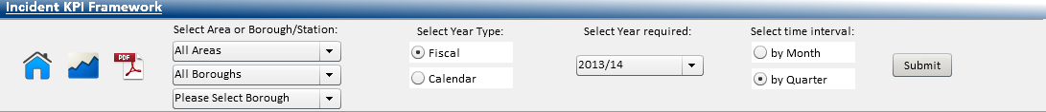

You have the option to select either a Fiscal Year or a Calendar Year. Select the required year. You also have the option to select to show information by month or by quarter.

Click 

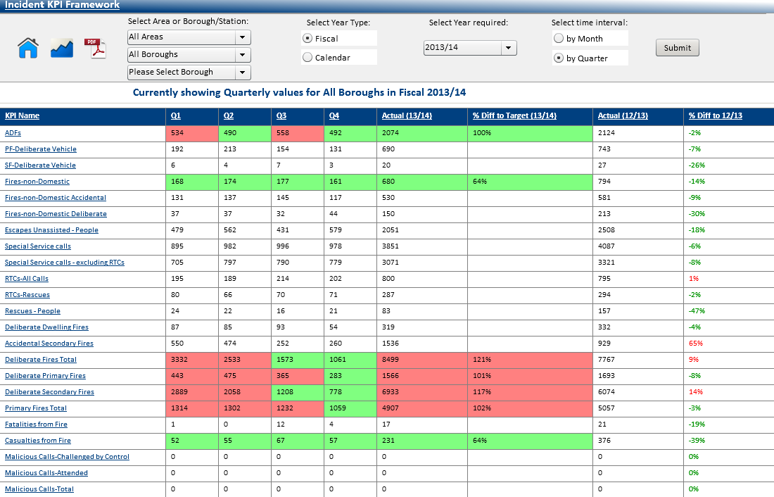

The dashboard will refresh and display data based on the criteria specified. You may need to use the scroll bar to the right of the screen to display the complete list of KPI’s.

To display performance information for an Area, simply select the Area from the dropdown list.

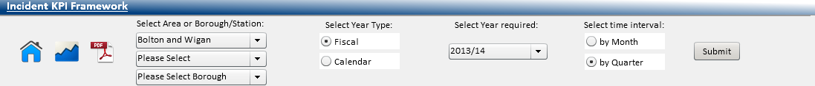

Click  as before, the dashboard will refresh and display data based on the criteria specified.

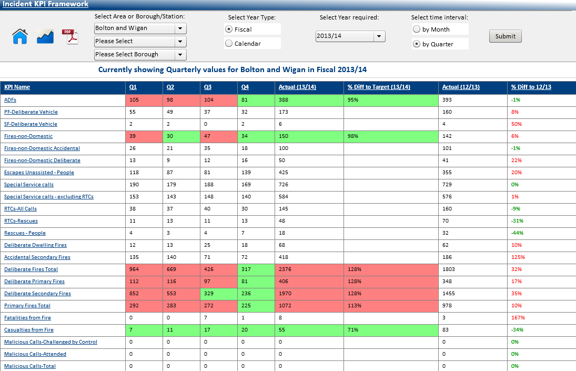

You can also view the information at a Borough/Station level. Click to select the Borough and Station from the dropdown lists. (You can just select a Borough)

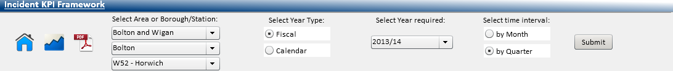

Click  as before, the dashboard will refresh and display data based on the criteria specified.

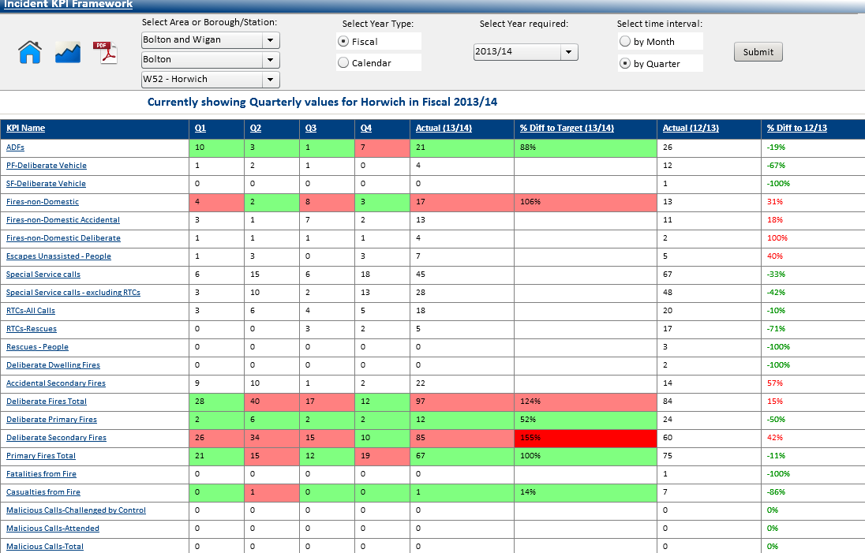

The KPI’s that have targets set against them will display **green** if within the target and **red** if over target. When you hover over any of the figures, it will display the **actual** target figure.

Example: 



Each of the KPI’s that are listed on the left hand side are hyperlinked. By clicking on the KPI it will take you to the **Incident KPI Tool** anddisplay the selected KPI, to allow further interrogation of the data.

The example below shows the display after selecting the **Fires–non-Domestic** **KPI**

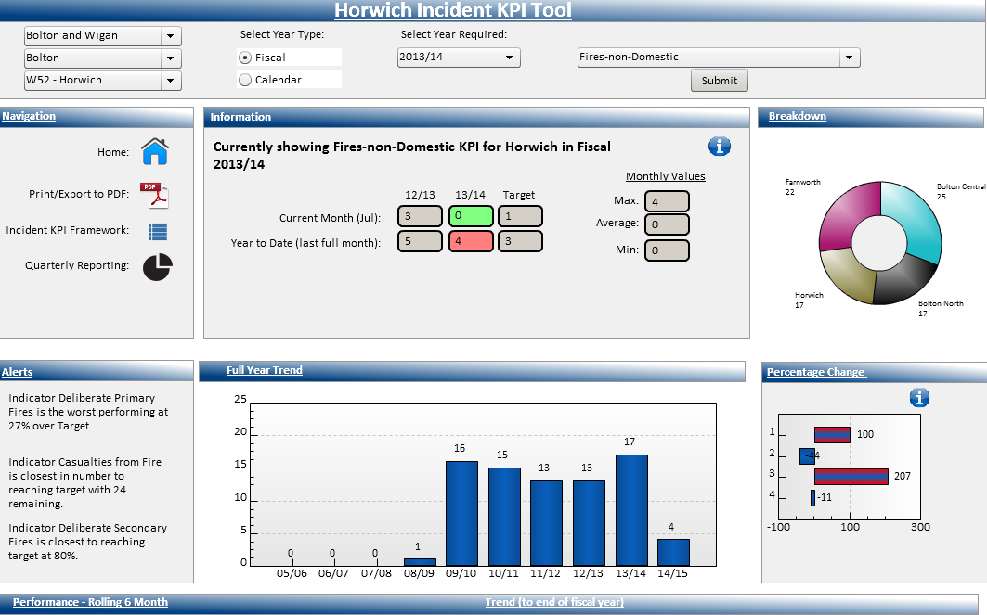

The criteria that you specified in the Incident KPI Framework Tool will automatically feed through and the relevant data will be displayed.

To return to the Home Page click 

## Printing the Dashboards

The system has the ability to print the information displayed on the dashboards.

This is available wherever you see the PDF Icon  and when clicked the following will display.

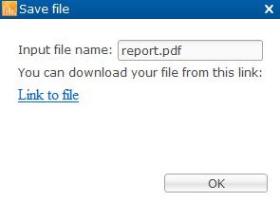

Click

The following message will display.



Click  this will then open up PDF with your dashboard.

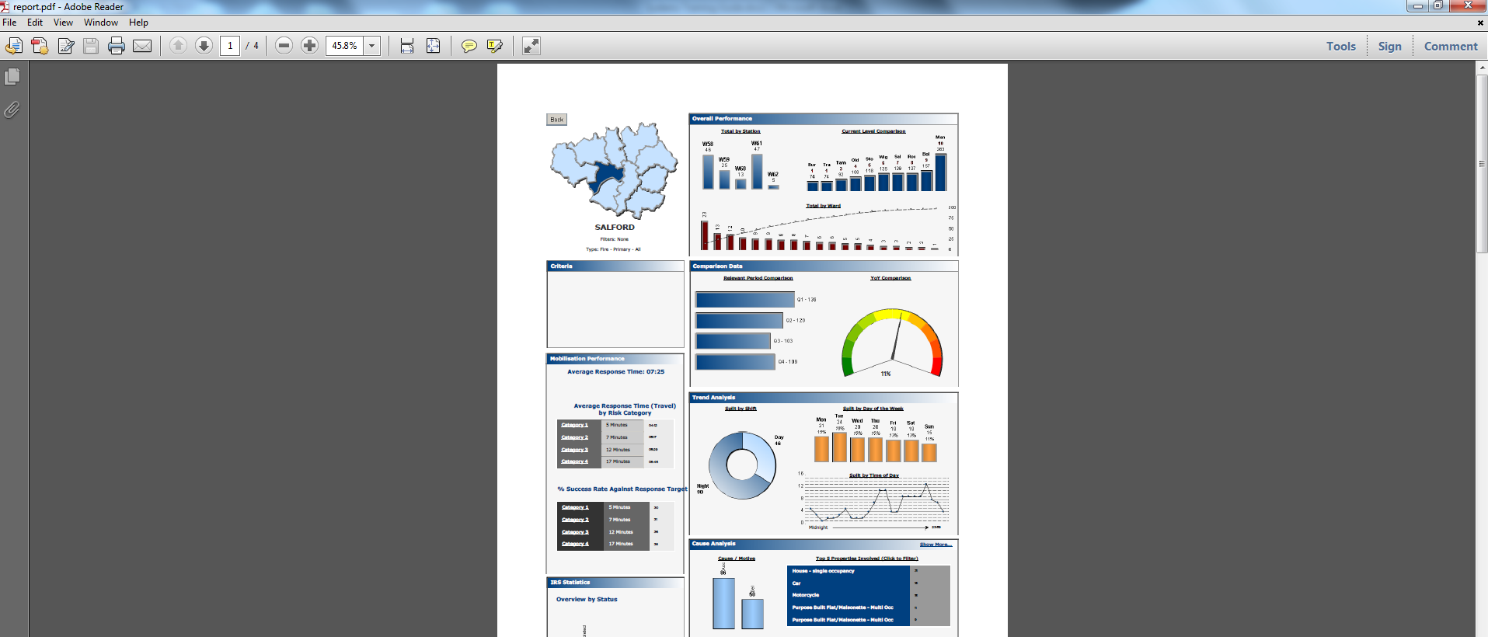

You would print in the usual way. Click  to close.



Click

You will be returned to the previous screen. To return to the Home Page click 

## Accessing the ‘Raw’ data

The dynamic dashboards, gives you the ability to drill down so you can access the ‘Raw’ data. To do this you would simply **double click** where you want to access the data from.

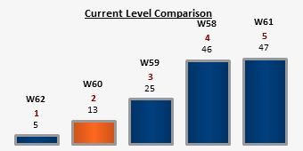

E.g. Double click to access the 13 Incidents for W60.

The following screen will display.

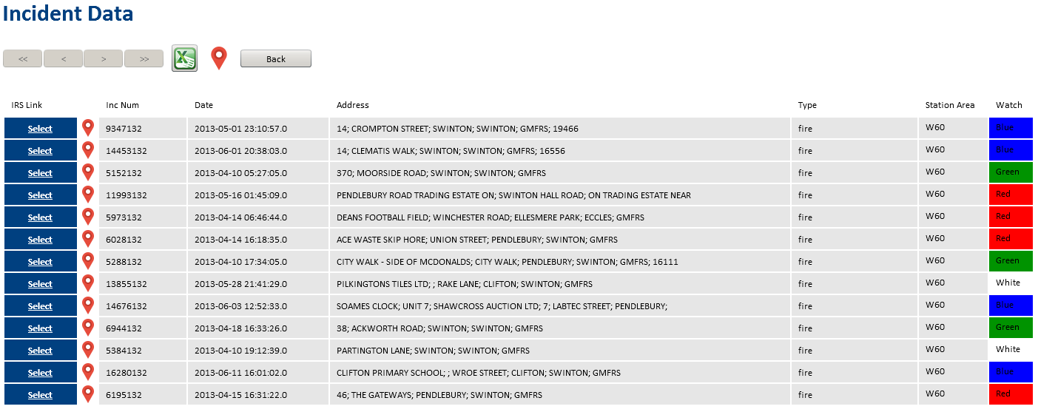

Here you will see a list of all the Incident Records, the Station Area and Watch will also be listed.

The chevrons  at the top of the screen allow you to scroll forwards and backwards through the pages of data, should you need to.

## Links to other Systems

Using the corresponding link from the Incident Data screen, you can open up an incident within the Incident Recording System. Click on the  button next to the incident you wish to view.

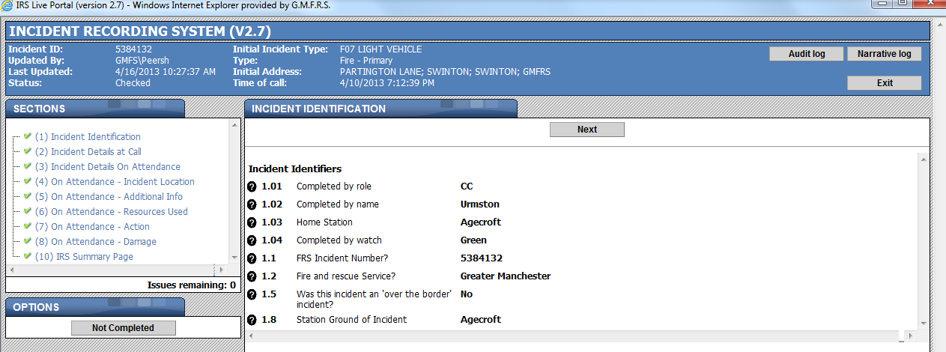

The incident will display, you can view the details in the usual way.

Click  to close. You will be returned to the previous screen.

* Where the data is displayed as a table, the raw data is accessed by **double clicking** onto the actual number. See below as an example.

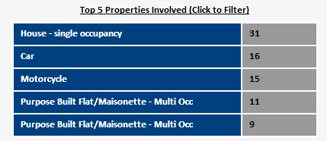

You can also see where the incident took place via google maps. This would be done by clicking the  next to the incident you wish to view. To see all the incidents plotted on the map you would need to click the icon at the top of the screen.

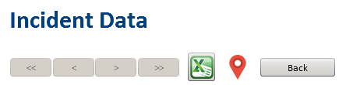

## Exporting Data

Information can also be exported into Excel.



From the list of Incidents click  when clicked the following will display:



Click

The following message will display.



Click  to open Excel. You will need to click 

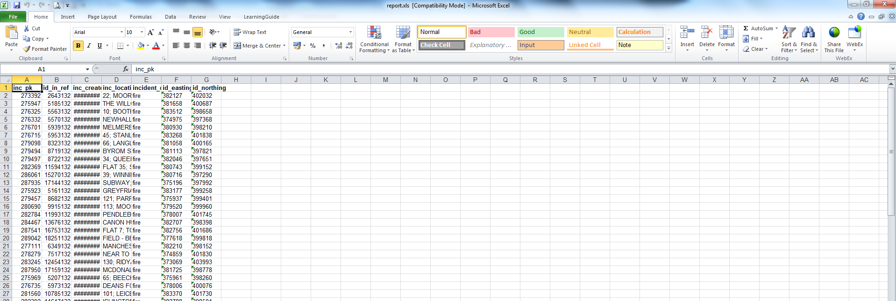

You will then be able to work with the Excel spreadsheet.

Click  to close. You will be returned to the previous screen.



Click

You will be returned to the previous screen. To return to the Home Page click 

# Help and Support

**Should you require any further help or assistance when using the Performance Portal contact a member of the** [**Systems Training**](mailto:systemstraining@manchesterfire.gov.uk) **and Support Team on**

**0161 608 4038 or**

[**performance@manchesterfire.gov.uk**](mailto:performance@manchesterfire.gov.uk)